**Install DVWA In Kali Linux**

Damn Vulnerable Web App (DVWA) is a PHP/MySQL web application that is damn vulnerable. Its main goals are to be an aid for security professionals to test their skills and tools in a legal environment, help web developers better understand the processes of securing web applications and aid teachers/students to teach/learn web application security.

1. Install link : <https://dvwa.co.uk/>

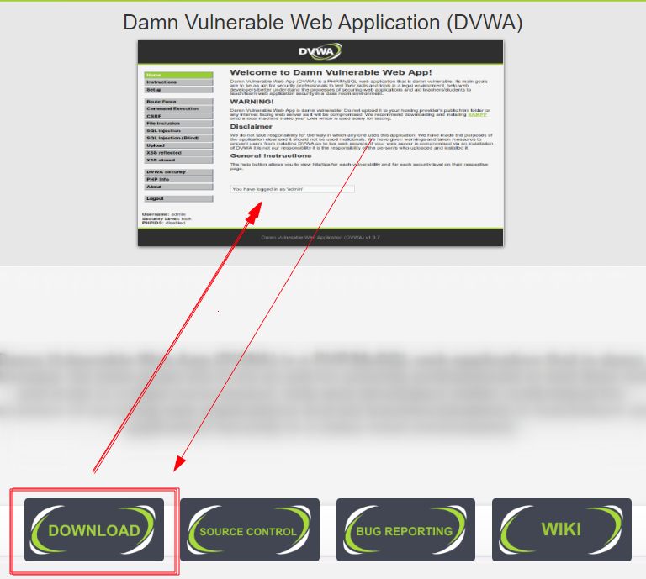

## Step 1: Download Damn Vulnerable Web Application (DVWA)

To get started, we will need to clone the DVWA GitHub into our /var/www/html directory. That is the location where Localhost files are stored in Linux systems. Launch the Terminal and change our directory to the /var/www/html directory with the command below.

$ cd /var/www/html

Sample Output:  


Once in this directory, we will [clone the DVWA GitHub repository](https://www.golinuxcloud.com/git-clone-repository/) with the command below.

$ sudo git clone https://github.com/digininja/DVWA

Sample Output: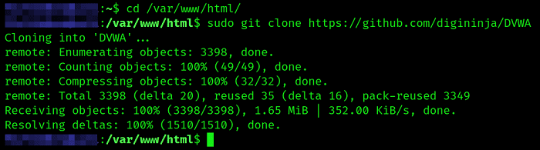

Advertisement

After cloning, we can rename the DVWA folder to dvwa. That is not mandatory, but it makes work easier when executing multiple commands.

## Step 2: Configure DVWA

After downloading cloning DVWA in our /var/www/html directory, we still need to do some minor configurations. To get started, let’s set read, write, and execute permissions to the DVWA directory. Execute the command below.

$ chmod -R 777 DVWA/

Sample Output:  


After successfully executing the command, we need to set up the user and password required to access the database. Change directory with the command below.

$ cd dvwa/config

you will see the config.inc.php.dist file. we will create a copy of this file called config.inc.php and the original config.inc.php.dist

Execute the command below.

sudo cp config.inc.php.dist config.inc.php

Sample Output:  
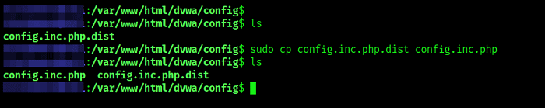

. We will set db_user as user and db_password as pass. Feel free to use a different username or password.

Advertisement

$ sudo nano config.inc.php

Sample Output:  
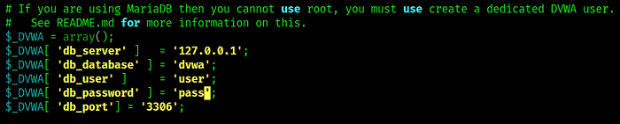

Save the file (Ctrl + O, then Enter) and Exit (Ctrl + X). That’s it! We are done configuring the DVWA Web application. Let’s move on and configure the database (MySQL).

## Step 3: Install MySQL on Kali Linux

By default, MySQL comes pre-installed on Kali Linux. If that's not the case for you or maybe you messed up with MySQL, we can go ahead and install it manually. If you have worked with Debian-based distributions, MySQL comes in two packages:

* mysql-server
* mysql-client

sudo apt install default-mysql-server

Sample output:[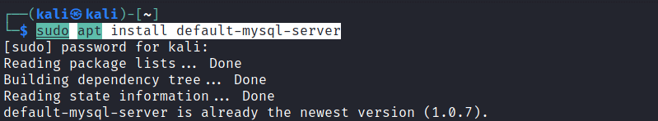](https://www.golinuxcloud.com/wp-content/uploads/Install-MySQL.png)

## Step 4: Configure MySQL Database

Start the Mysql service with the command below:

$ sudo service mysql start

You can check whether the service is running using the systemctl status command below.

$ systemctl status mysql

Sample Output:  
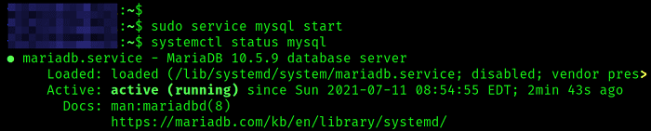

Login to the MySQL database using the command below as root. If you have another name set for the superuser in your system, use it instead of root.

$ sudo mysql -u root -p

You will see a prompt to enter the password. Just hit Enter since we haven’t set any password. MySQL will open, as shown in the image below:  
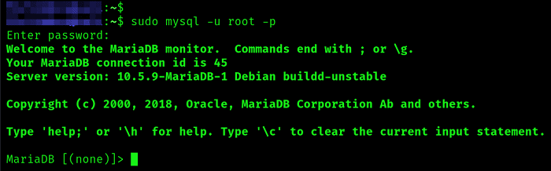

We will create a new user with the username and password set in our DVWA application configuration file. In my case, the username was ‘user,' and the password was ‘pass.’ The server we are using is Localhost (127.0.0.1). Use the command below.

create user 'user'@'127.0.0.1' identified by 'pass';

Sample Output:  
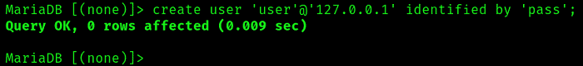

We need to grant this new user privilege over the dvwa database. Execute the command below.

grant all privileges on dvwa.* to 'user'@'127.0.0.1' identified by 'pass';

Up to this point, we are through with configuring both the DVWA application and the MySQL database. Type exit to close the database.  
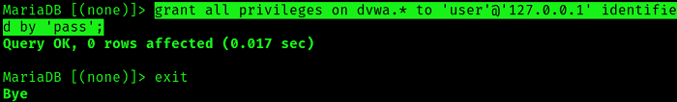

## Step 6: Configure Apache Server

Now, we need to configure the server. Use the command below to change your location on the Terminal to point to /etc/php/8.1/apache2 directory.

$ cd /etc/php/8.1/apache2

$ ls /etc/php

In the /etc/php/8.1/apache2, when you execute the ls command, you will see a file called php.ini. That is the file we will edit to configure our localhost server. Use the command below to open it using the nano editor.

$ sudo nano php.ini

Scroll down and look for these two lines: allow_url_fopen and allow_url_include. Set them both as On . Save the file (Ctrl + O, then Enter) and Exit (Ctrl + X).

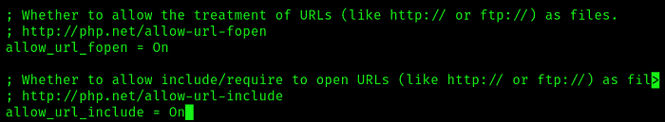

Start Apache server using the command below:

$ sudo service apache2 start

To check whether the service started successfully, use the status command.

$ systemctl status apache2

Sample Output:  
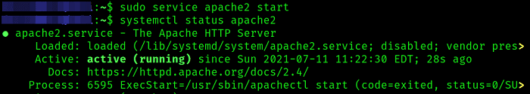

## Step 7: Access DVWA on Your Browser

## Open your browser and enter the URL:

http://127.0.0.1/dvwa/

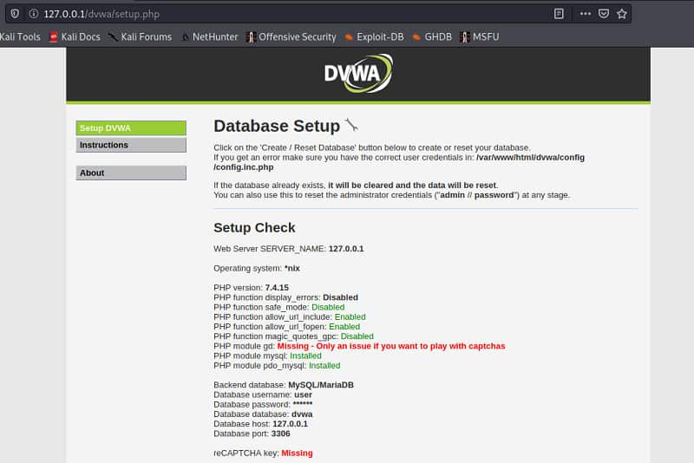

You might see the errors colored in red as in the image above. Don’t panic! Scroll down and click the Create / Reset Database button.

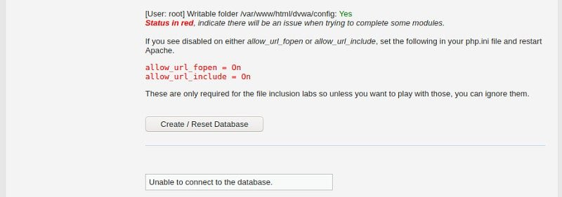

That will create and configure the database. After some time, you will be redirected to the DVWA login page. Log in with these credentials:

* Username - admin
* Password – password